Word Template J-BPE for One Column

Aleksandr Ometov^{1,2}, Mary Y. Writter³ and John X. Ceur^{4*}

¹ University 1, Address, City, Index, Country
² University 2, Address, City, Index, Country
³ University 3, Address, City, Index, Country
⁴ University 2, Address, City, Index, Country
E-mail: *e@mail.address

Abstract
Abstract text.

Keywords
Keyword 1; keyword 2; … ; Keyword N.

Introduction
Paragraph text.

An example of numbered list is as following.
- Item 1
- Item 2
- Item 3
An example of bulleted list is as following.
- Item 1
- Item 2
- Item 3

First level heading
Paragraph text.

Second level heading
Paragraph text.

Third level heading
An example of table styling. It is recommended to add cross references to tables, i.e., please, check Table 1.

Table 1 – Table title.
Head 1 | Head 2 | Head 3
A | Text | Text
B | Text | Text
C | Text | Text

An Example of Eq. (1)
$$E=mc^{2},$$ | (1)
where ...
An example of the Fig. 1.

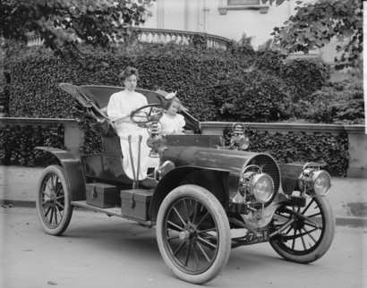
Fig.1 – Example figure.

Disclosures
All authors should declare that there is no conflict of interests in this paper.

Acknowledgements
Identification of funding sources and other support, and thanks to individuals and groups that assisted in the research and the preparation of the work should be included in an acknowledgment section, which is placed just before the reference section in your document.

References
- Normal book (authors). E. S. Koay, and N. Walmsley, A Primer of Chemical Pathology, World Scientific Publishing, Singapore (1996).
- Chapter in a book (editors). N. B. Slepecky, “Structure of the mammalian cochlea,” Chap. 2 in The Cochlea, P. Dallos, A. N. Popper, R. R. Fay (Eds.), Springer-Verlag, New York, 45-129 (1996). Doi: doi/number.
- Edition. A. S. M. Lim, and I. J. Constable, A Colour Atlas of Ophthalmology, 4th Edition, World Scientific Publishing, Singapore (2001).
- Journal article. A. Hildersheim, and P. H. Levine, “Etiology of nasopharyngeal carconoma: A review,” Epidemiological Review 15(2), 466-485 (1996). Doi: doi/number.
- Electronic resources. W. S. Rasband, ImageJ, U. S. National Institutes of Health, Bethesda, Maryland, USA, http://rsb.info.nih.gov/ij/ (1997-2006).
- To be published. X. Xu, J. A. Spencer, K. K. Lin, E. I. Kudryavtseva, and B. Andersen, “Characterization of mice expressing a dominant negative Clim in epithelial tissues” [in Press].

