Word Template

N. Surname^{a,b}, N. Surname^{b,c}

- University 1, Address, City, Index, Country
- University 1, Address, City, Index, Country
- University 1, Address, City, Index, Country

Abstract
All articles must have Abstract. The abstract should give the representatives an idea of the main results and conclusions. The length of the abstract should not be 200 words.

Keywords
Paper template, paper formatting, at least three keywords

Introduction
These rules can be used as a template of the abstract papers for the ITNT Conference using the text editor Microsoft Word. The volume of the abstract paper should not exceed 2 pages. It should allow to identify the essence of the research and conduct their expert assessment. The paper must contain mandatory parts: Introduction, Conclusion and References.
The Calibri font should be used for the title of the article, headings, titles of figures, and tables. The rest of the text is formatted using Times New Roman font. The size used for the title of the article is 17 pt, for headings is 14 pt, the rest of the text is drawn up in 11 pt.

First and second level heading
Separation of the text is optional and is left to the discretion of the author.

Section numbering
Sections should be numbered with numbers separated by a dot and separated by a space from the title name:
- First level headings are numbered as 1., 2., 3. and etc.
- Second level headings are numbered as 2.1., 2.2., 2.3. and etc.

Formatting formulas, figures and tables
An Example of equation
$$E=mc^{2},$$ | (1)
where ...

An example of table styling. It is recommended to add cross references to tables, i.e., please, check Table 1. The style should be switched to Normal.

Table 1
Table title
Head 1 | Head 2 | Head 3
A | Text | Text
B | Text | Text
C | Text | Text
An example of the Figure 1 is presented below.

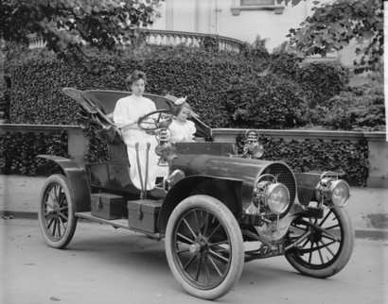
Figure 1: Example figure

Acknowledgements
Identification of funding sources and other support, and thanks to individuals and groups that assisted in the research and the preparation of the paper should be included in an acknowledgment section, which is placed just before the reference section in the document.

4. References
[1] Soifer, V. Iterative Methods for Diffractive Optical Elements Computation / V. Soifer, V. Kotlyar, L. Doskolovich – London: Taylor & Francis Ltd., 1997. – 244 p.
[2] Physical Values: Reference Book / edited by I.S. Grigorjev and E.Z. Mejlihov. – Moscow: “Energoatomizdat” Publisher, 1991. – 1232 p. – (in Russian).
[3] Doskolovich, L.L. A gradient method for design of multiorder varied-depth binary diffraction gratings – a comparison / L.L. Doskolovich, S.I. Kharitonov, O.I. Petrova, V.A. Soifer // Opt. And Lasers in Eng. – 1998. – Vol. 29(4). – P. 249–259.
[4] Kadomcev, B.B. Dynamics and the Information / B.B. Kadomcev // Izbrannye trudy: in 6 volumes. – Moscow: “Fizmatlit” Publisher, 2003. – V. 2. – P. 508–515.
[5] ITNT Conference Web Site [Electronic resource]. — Access mode: http://itnt-conf.org (01.12.2016)

